India’s Agriculture Crop Production Analysis(1997-2021)

1.INTRODUCTION

1.1 Overview

The agriculture sector is one of the most important industries in the Indian economy. India: Gross domestic product (GDP) in current prices from 1987 to 2028 (in billion U.S. dollars) India: Distribution of the workforce across economic sectors from 2011 to 2021

*1.2 Purpose*

Organic agriculture has fed India for centuries and it is again a growing sector in India. Organic production offers clean and green production methods without the use of synthetic fertilisers and pesticides and it achieves a premium price in the market place. India has 6,50,000 organic producers, which is more than any other country.

2

2. Problem Definition & Design Thinking

2.1 Ideation & Brainstorming Map

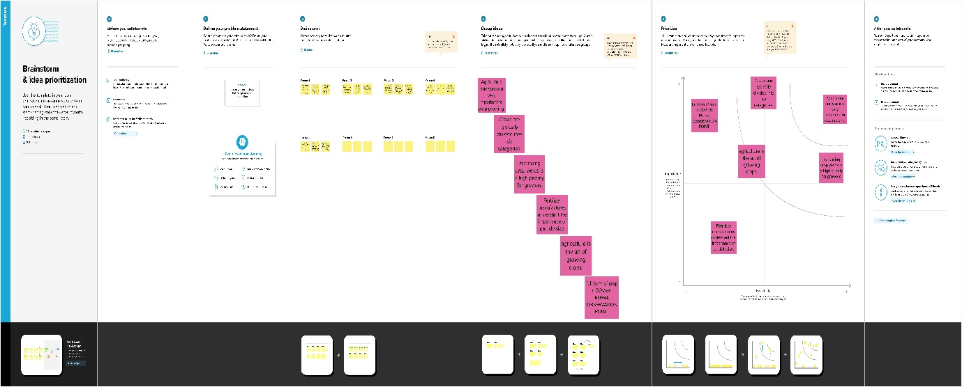

2.2 Empathy Map

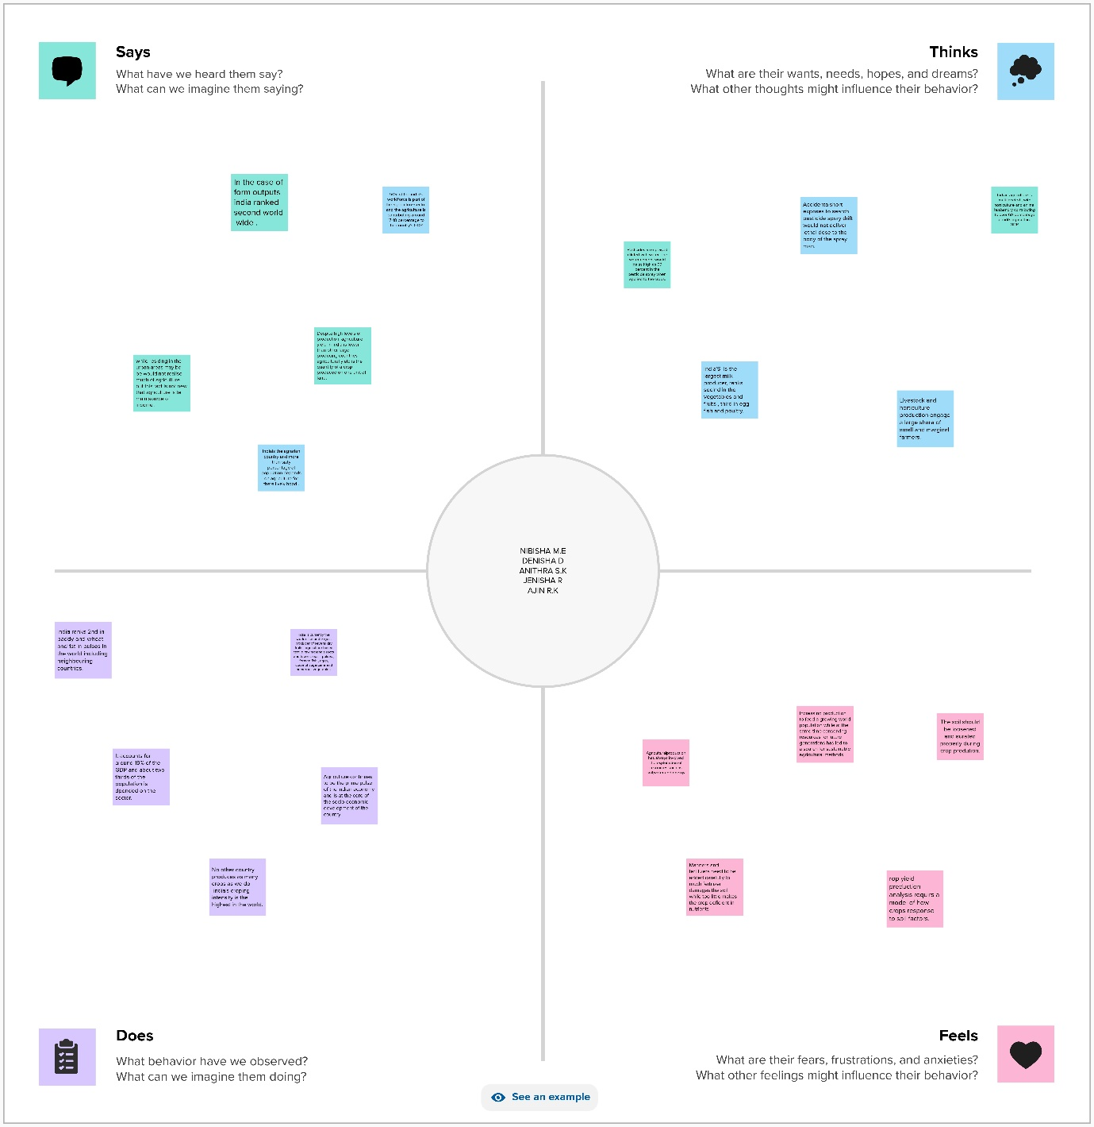

3. Result

Dashboard

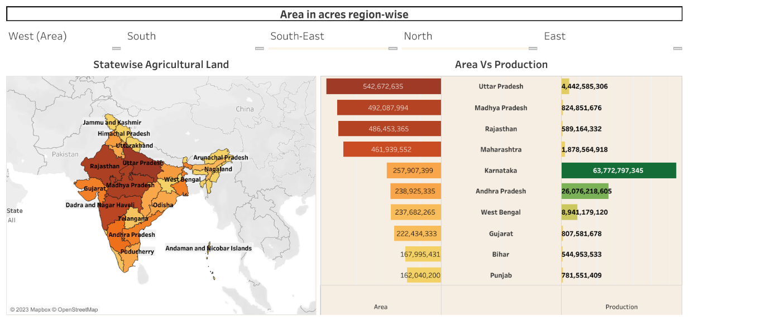

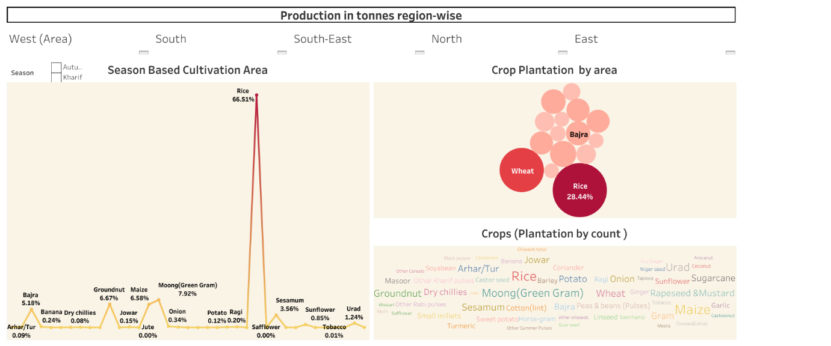

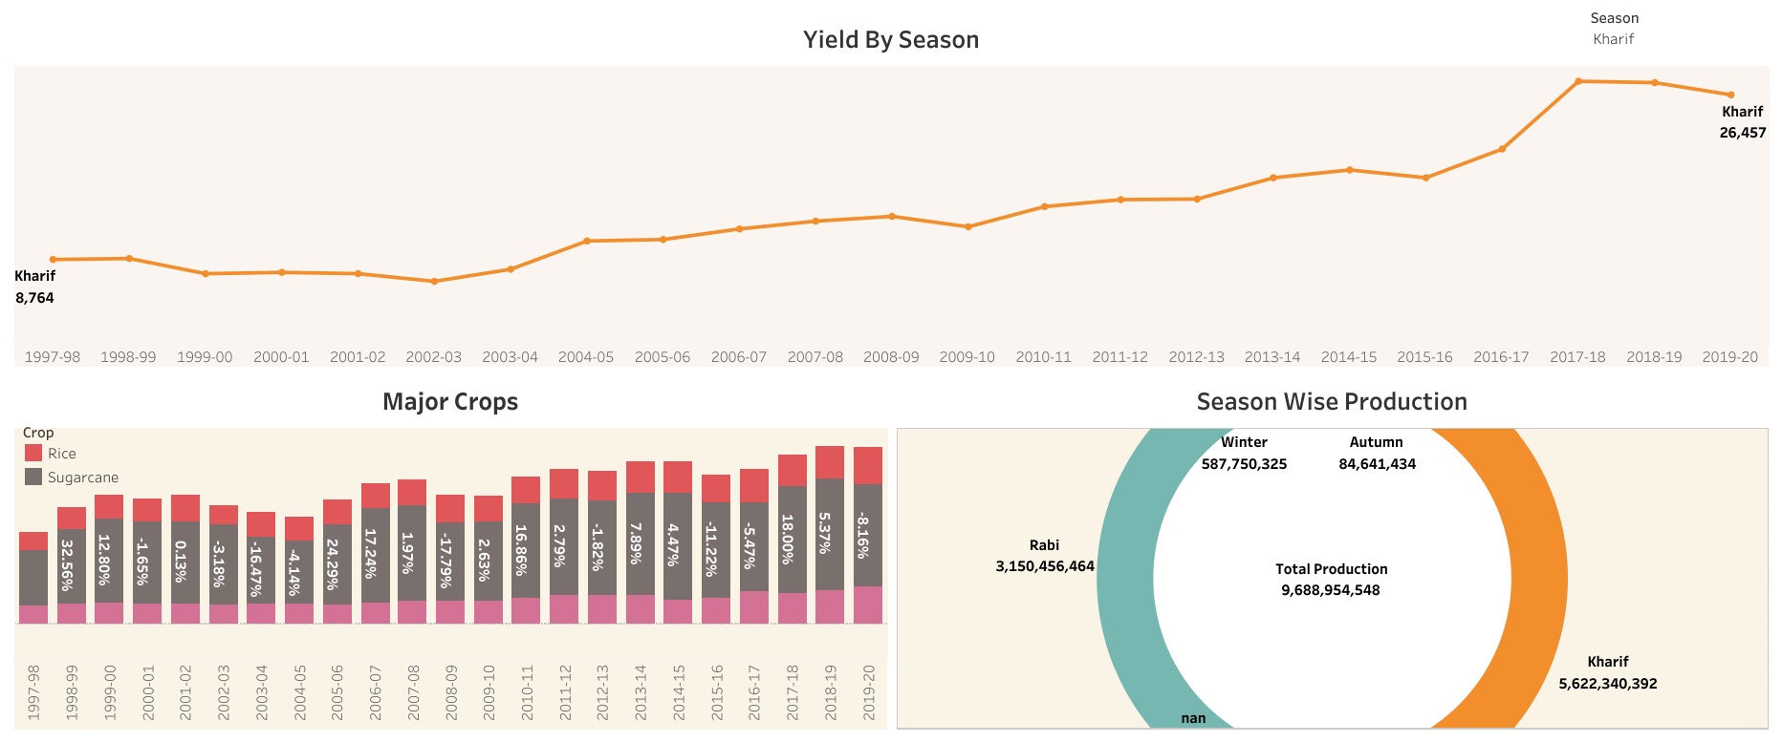

Story

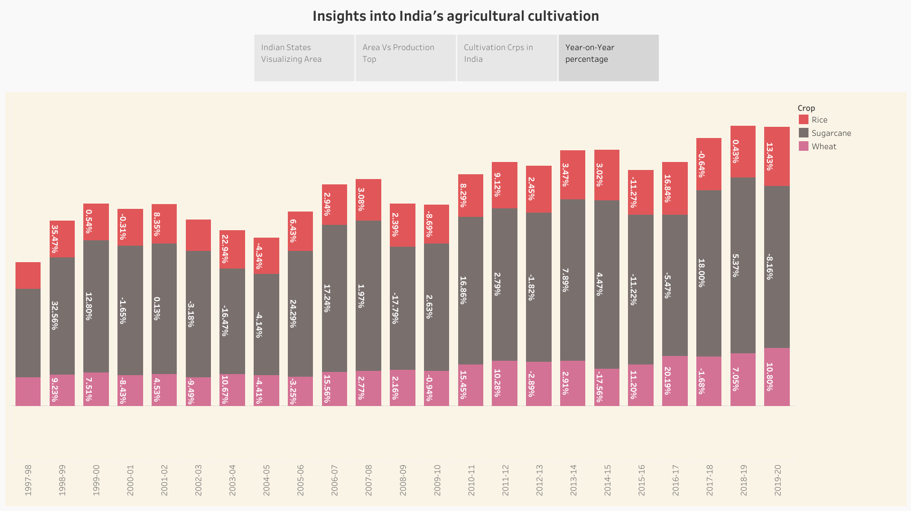

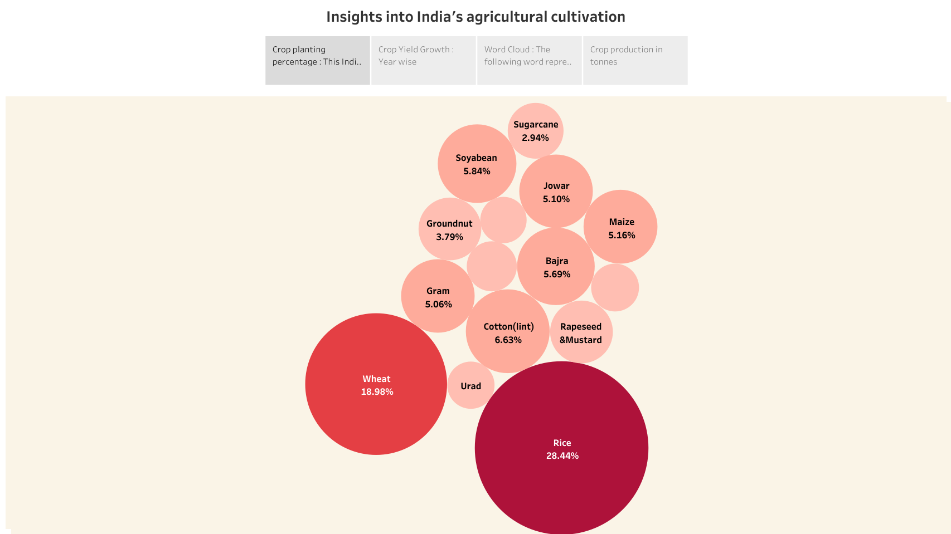

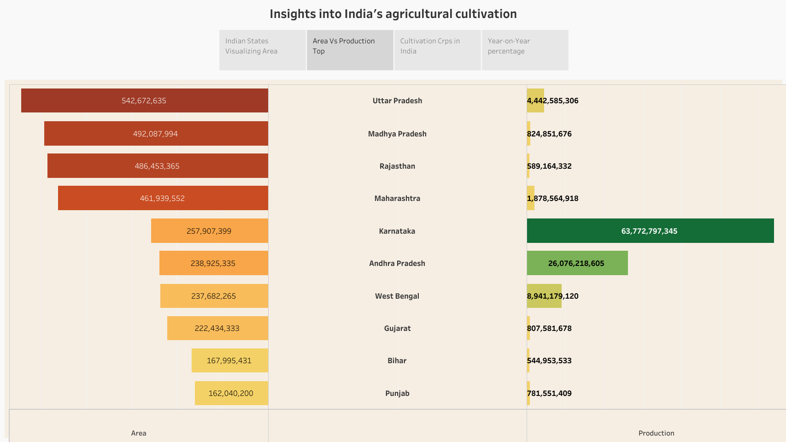

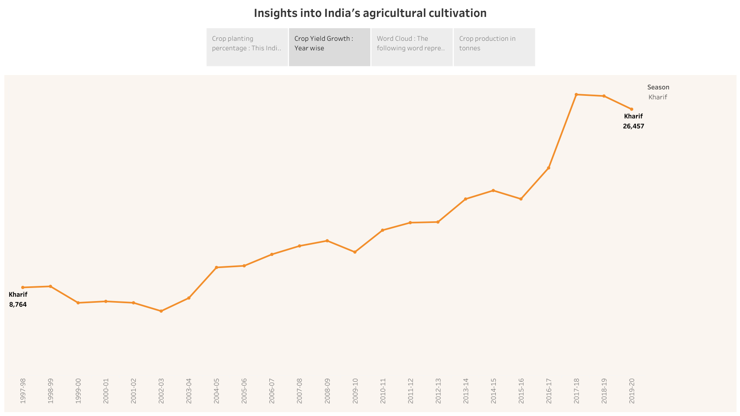

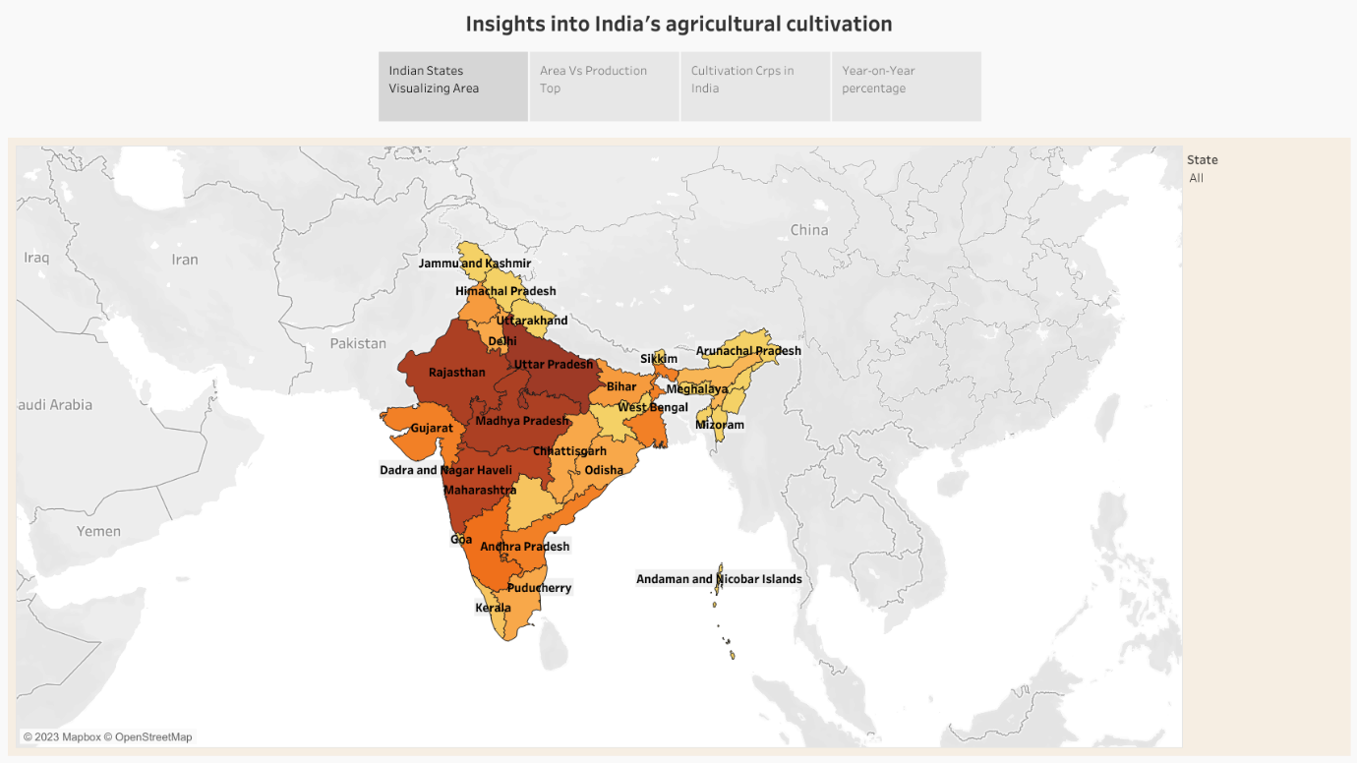

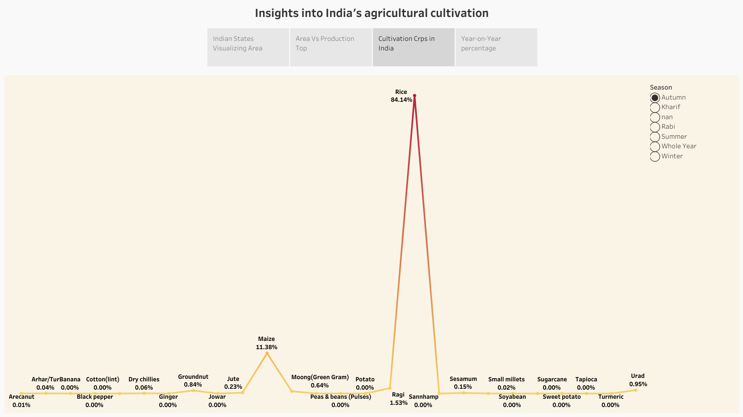

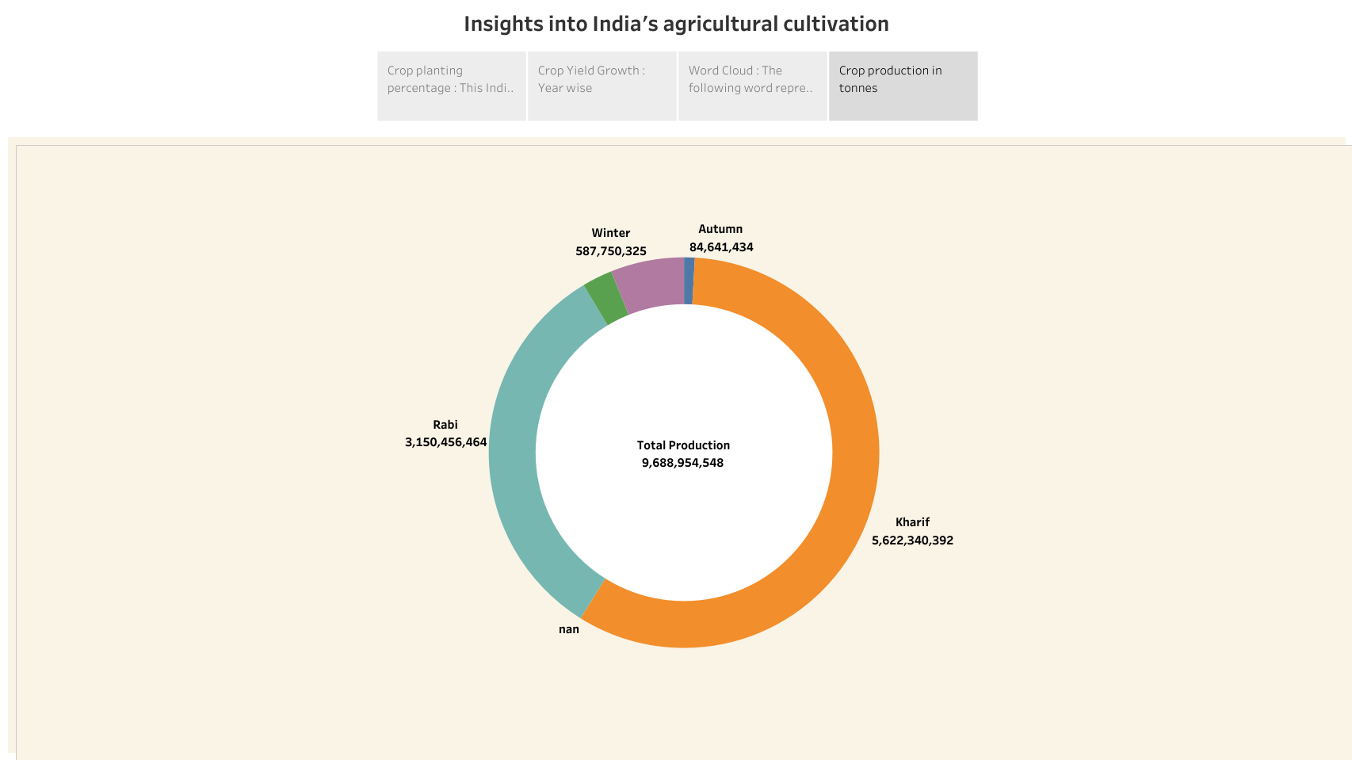

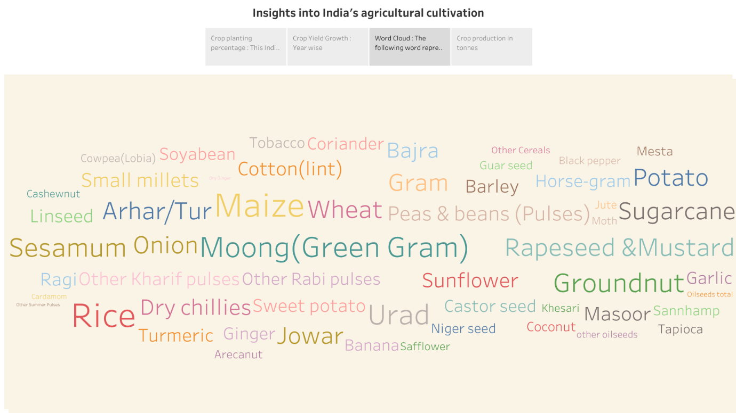

4. Advantages

* There is overall increase in yield of crops mainly due to maintaining physical-chemical properties of soil.
* It helps in controlling insects,pest and soil borne diseases.
* Prevent or limit periods of peak requirements of irrigation water.
* Provides employment opportunity to the rural agricultural as well as non-agricultural labours.
* Provides food to the second biggest population of cattel in the world.

Disadvantages

* Soil erosion can also be brought on by agricultural practices.
* Increased use of fertilizers has led to the loss of soil fertility.
* Water quality issue can arise from agricultural pollution in both surface and ground water.
* It involves the delibrate removalof forests .
* The majority of soil depletion is caused by the overuse of land and the products that we apply to it.

5. Application

* India is the world’s largest producer of milk pulses and jute.
* India ranks as the second largest producer of rice, wheat, sugarcane, groundnut, vegetables, fruits and cotton.
* We presently produce 300 million tones (MT) of food grains.
* India is a country with an agrarian economy ,with over 54% of the countries land classified as arable and the agricultural industry comprising of half of the labour market.
* Agricultural supply chains in the developing world face the daunting task of feeding a growing population in the coming decades.

6.Conclusion

Sustainable agriculture gives equal weight to environmental , social and economic concerns in agriculture. Agriculture sustainability rests on the needs of the principle that we must meet the needs of the present without compromising the ability of the future generation to meet their own needs.

7.Future Scope

* Agriculture sector have an enormous scope in India of the future reference because agriculture sector is the largest sector with 49% of countries population works in the agriculture sector by occupation.
* India is aso a developing country with about 16% of its GDP is contributing by this sector.
* The future India’s Agricultural Crop Production the various factors such as technological advancement, climate change, government policies and global market demands.
* Continued investement in agriculture research, sustainable forming practices and infrastructure development could enhance productivity.
* However, challenges like water scarcity and climate change impact might also pose threats. It’s essential for policymakers and farmers to adapt to changing the conditions for a sustainable agriculture future.